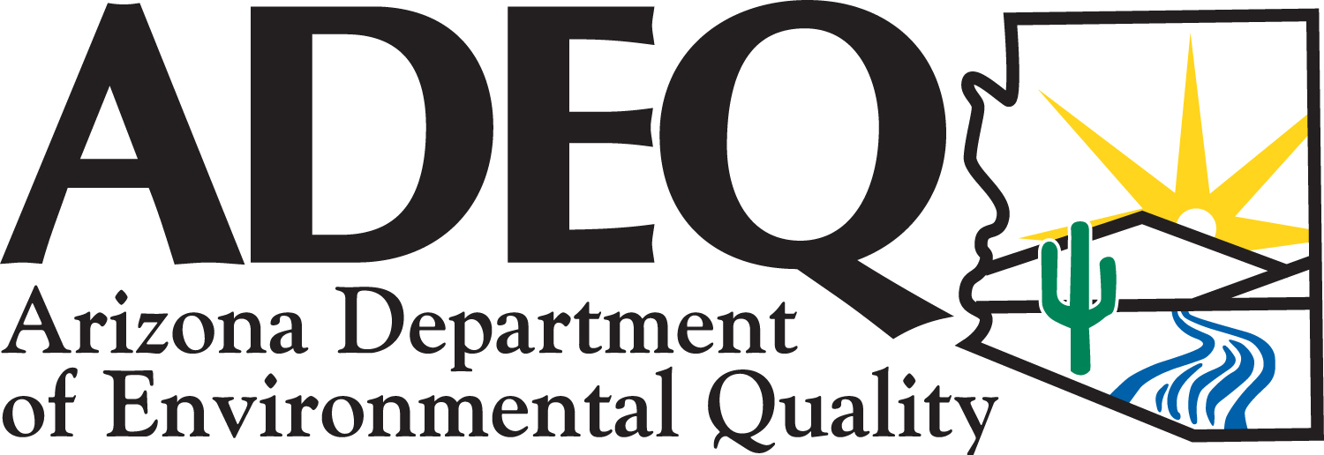
Consumer Confidence Report for Calendar Year 2020
Este informe contiene informactión muy importante sobre el aqua usted bebe.
Tradúscalo ó hable con alguien que lo entienda bien.

Public Water System ID Number | Public Water System Name
AZ04-08014 | Hatch Valley DWID
Contact Name and Title |  | Phone Number | E-mail Address
Brandi Allen, Book Keeper |  | 928-377-2057 | hatchvalleydwid@yahoo.com
We want our valued customers to be informed about their water quality. If you would like to learn more about public participation or to attend any of our regularly scheduled meetings that are held on the second Tuesday of every month at 7pm at Valentine Elementary School in Truxton, please contact Brandi at 928-377-2057 for additional opportunity and meeting dates and times.
Drinking Water Sources
The sources of drinking water (both tap and bottled water) include rivers, lakes, streams, ponds, reservoirs, springs, and wells. As water travels over the surface of the land or through the ground, it dissolves naturally-occurring minerals, and in some cases, radioactive material, and can pickup substances resulting from the presence of animals or from human activity.
In order to ensure that tap water is safe to drink, EPA prescribes regulations which limit the amount of certain contaminants in water provided by public water systems. Food and Drug Administration (FDA) regulations establish limits for contaminants in bottled water which must provide the same protection for public health.
Our water source(s): | Hatch Valley DWID has two ground-water wells that serve the community of Truxton, AZ. The water is pumped from the Truxton Aquifer.

Drinking Water Contaminants
Microbial Contaminants: Such as viruses and bacteria that may come from sewage treatment plants, septic systems, agricultural livestock operations, and wildlife  Inorganic Contaminants: Such as salts and metals that can be naturally-occurring or result from urban stormwater runoff, industrial or domestic wastewater discharges, oil and gas production, mining, or farming  Pesticides and Herbicides: Such as agriculture, urban storm water runoff, and residential uses that may come from a variety of sources | Organic Chemical Contaminants: Such as synthetic and volatile organic chemicals, which are by-products of industrial processes and petroleum production, and also may come from gas stations, urban storm water runoff, and septic systems.  Radioactive Contaminants: That can be naturally occurring or be the result of oil and gas production and mining activities.

Vulnerable Population
Drinking water, including bottled water, may reasonably be expected to contain at least small amounts of some contaminants. The presence of contaminants does not necessarily indicate that water poses a health risk. Some people may be more vulnerable to contaminants in drinking water than the general population.

Immuno-compromised persons such as persons with cancer undergoing chemotherapy, persons who have undergone organ transplants, people with HIV-AIDS or other immune system disorders, some elderly, and infants can be particularly at risk from infections. These people should seek advice about drinking water from their health care providers.

For more information about contaminants and potential health effects, or to receive a copy of the U.S. Environmental Protection Agency (EPA) and the U.S. Centers for Disease Control (CDC) guidelines on appropriate means to lessen the risk of infection by Cryptosporidium and microbiological contaminants call the EPA Safe Drinking Water Hotline at 1-800-426-4791.
Source Water Assessment
- Based on the information currently available on the hydrogeologic settings and the adjacent land uses that are in the specified proximity of the drinking water source(s) of this public water system, the Arizona Department of Environmental Quality (ADEQ) has given a high risk designation for the degree to which this public water system drinking water source(s) are protected. A designation of high risk indicates there may be additional source water protection measures which can be implemented on the local level. This does not imply that the source water is contaminated nor does it mean that contamination is imminent. Rather, it simply states that land use activities or hydrogeologic conditions exist that make the source water susceptible to possible future contamination.
Further source water assessment documentation can be obtained by contacting ADEQ.
Definitions
Treatment Technique (TT): A required process intended to reduce the level of a contaminant in drinking water  Level 1 Assessment: A study of the water system to identify potential problems and determine (if possible) why total coliform bacteria was present  Level 2 Assessment: A very detailed study of the water system to identify potential problems and determine (if possible) why an E. coli MCL violation has occurred and/or why total coliform bacteria was present  Action Level (AL): The concentration of a contaminant which, if exceeded, triggers treatment, or other requirements  Maximum Contaminant Level (MCL): The highest level of a contaminant that is allowed in drinking water  Maximum Contaminant Level Goal MCLG): The level of a contaminant in drinking water below which there is no known or expected risk to health  Maximum Residual Disinfectant Level (MRDL): The level of disinfectant added for water treatment that may not be exceeded at the consumer’s tap  Maximum Residual Disinfectant Level Goal (MRDLG): The level of disinfectant added for treatment at which no known or anticipated adverse effect on health of persons would occur | Minimum Reporting Limit (MRL): The smallest measured concentration of a substance that can be reliably measured by a given analytical method  Millirems per year (MREM): A measure of radiation absorbed by the body  Not Applicable (NA): Sampling was not completed by regulation or was not required  Not Detected (ND or <): Not detectable at reporting limit  Nephelometric Turbidity Units (NTU): A measure of water clarity  Million fibers per liter (MFL)  Picocuries per liter (pCi/L): Measure of the radioactivity in water  ppm: Parts per million or Milligrams per liter (mg/L)  ppb: Parts per billion or Micrograms per liter (µg/L)  ppt: Parts per trillion or Nanograms per liter (ng/L)  ppq: Parts per quadrillion or Picograms per liter (pg/L)
  ppm x 1000 = ppb
  ppb x 1000 = ppt
  ppt x 1000 = ppq
Lead Informational Statement:
Lead, in drinking water, is primarily from materials and components associated with service lines and home plumbing. If present, elevated levels of lead can cause serious health problems, especially for pregnant women and young children. Hatch Valley DWID is responsible for providing high quality drinking water, but cannot control the variety of materials used in plumbing components. When your water has been sitting for several hours, you can minimize the potential for lead exposure by flushing your tap for 30 seconds to 2 minutes before using water for drinking or cooking. Information on lead in drinking water, testing methods, and steps you can take to minimize exposure is available from the Safe Drinking Water Hotline or at www.epa.gov/safewater/lead.

Water Quality Data – Regulated Contaminants
Microbiological (RTCR) | TT  Violation  Y or N | Number of Positive Samples | Positive  Sample(s) Month & Year | MCL | MCLG | Likely Source of Contamination
E. Coli | N | 0 | N/A | 0 | 0 | Human and animal fecal waste
Fecal Indicator (From GWR source)  (coliphage, enterococci and/or E. coli) | N | 0 | N/A | 0 | 0 | Human and animal fecal waste
Lead & Copper | MCL  Violation  Y or N | 90th Percentile | Number of Samples Exceeds AL | AL | ALG | Sample Month & Year | Likely Source of Contamination
Copper (ppm) | N | 0.079 | N | 1.3 | 1.3 | 7/2018 | Corrosion of household plumbing systems; erosion of natural deposits
Lead (ppb) | N | 1.7 | N | 15 | 0 | 7/2018 | Corrosion of household plumbing systems; erosion of natural deposits
Inorganic Chemicals  (IOC) | MCL  Violation  Y or N | Running Annual Average (RAA) OR Highest Level Detected | Range of All Samples  (Low-High) | MCL | MCLG | Sample Month & Year | Likely Source of Contamination
Arsenic¹ (ppb) | N | 5.7 | 5.7 | 10 | 0 | 3/2020 | Erosion of natural deposits, runoff from orchards, runoff from glass and electronics production wastes
Barium (ppm) | N | 0.017 | 0.017 | 2 | 2 | 3/2020 | Discharge of drilling wastes; discharge from metal refineries; Erosion of natural deposits
Chromium (ppb) | N | 22 | 22 | 100 | 100 | 3/2020 | Discharge from steel and pulp mills; Erosion of natural deposits
Fluoride (ppm) | N | 0.36 | 0.36 | 4 | 4 | 3/2020 | Erosion of natural deposits; water additive which promotes strong teeth; discharge from fertilizer and aluminum factories
Nitrate² (ppm) | N | 5.5 | 5.2 - 5.5 | 10 | 10 | 3/2020 | Runoff from fertilizer use; leaching from septic tanks, sewage; erosion of natural deposits
Nitrite (ppm) | N | <0.05 | ND - <0.05 | 1 | 1 | 2/2017 | Runoff from fertilizer use; leaching from septic tanks, sewage; erosion of natural deposits
Sodium (ppm) | N | 22 | 22 | N/A | N/A | 3/2020 | Erosion of natural deposits
¹ Arsenic is a mineral known to cause cancer in humans at high concentration and is linked to other health effects, such as skin damage and circulatory problems. If arsenic is less than or equal to the MCL, your drinking water meets EPA’s standards. EPA’s standard balances the current understanding of arsenic’s possible health effects against the costs of removing arsenic from drinking water, and continues to research the health effects of low levels of arsenic.
² Nitrate in drinking water at levels above 10 ppm is a health risk for infants of less than six months of age. High nitrate levels in drinking water can cause “blue baby syndrome.” Nitrate levels may rise quickly for short periods of time because of rainfall or agricultural activity. If you are caring for an infant, and detected nitrate levels are above 5 ppm, you should ask advice from your health care provider.
Violation Summary (for MCL, MRDL, AL, TT, or Monitoring & Reporting Requirement)

Violation Type | Explanation, Health Effects | Time Period | Corrective Actions
NONE
Please share this information with other people who drink this water, especially those who may not have received this notice directly (for example, people in apartments, nursing homes, schools, and businesses). You can do this by posting this notice in a public place or distributing copies by hand or mail.

